**Dynamic Host Configuration Protocol (DHCP)**

**LAB # 05**



**Spring 2022**

**CSE303L-Data Communication & Computer Network**

Submitted by: **Ashfaq Ahmad**

Registration No: **19PWCSE1795**

Class Section: **B**

“On my honor, as student of University of Engineering and Technology, I have neither given nor received unauthorized assistance on this academic work.”

Student Signature: ______________

Submitted to:

**Eng: Faizullah**

April 18, 2022

**Department of Computer Systems Engineering**

**University of Engineering and Technology, Peshawar**

**CSE 303L: Data Communication and Computer Networks**

|  |  |  |  |  |
| --- | --- | --- | --- | --- |
| **Demonstration of Concepts** | **Poor(Does not meet expectation (1))**  The student failed to demonstrate a clear understanding of the assignment concepts | **Fair(Meet Expectation (2-3))**  The student demonstrated a clear understanding of some of the assignment concepts | **Good (Exceeds Expectation (4-5)**  The student demonstrated a clear understanding of the assignment concepts | **Score**  **30%** |
| **Accuracy** | The student mis-configured enough network settings that the lab computer couldn't function properly on the network | The student configured enough network settings that the lab computer partially functioned on the network | The student configured the network settings that the lab computer fully functioned on the network | **30%** |
| **Following Directions** | The student clearly failed to follow the verbal and written instructions to successfully complete the lab | The student failed to follow the some of the verbal and written instructions to successfully complete all requirements of the lab | The student followed the verbal and written instructions to successfully complete requirements of the lab | **20%** |
| **Time Utilization** | The student failed to complete even part of the lab in the allotted amount of time | The student failed to complete the entire lab in the allotted amount of time | The student completed the lab in its entirety in the al | **20%** |

**Credit Hours:**

**DHCP Experiment:**

In order to observe DHCP in action, we’ll perform several DHCP-related commands and

Capture the *DHCP messages* exchanged as a result of executing these commands. Do the following:

1. Begin by opening the Windows Command Prompt application (which can be found in your Accessories folder). As shown in Figure 1, enter **“*ipconfig /release*”.** The executable for *ipconfig* is in C:\windows\system32. This command releases your current IP address, so that your host’s IP address becomes0.0.0.0.

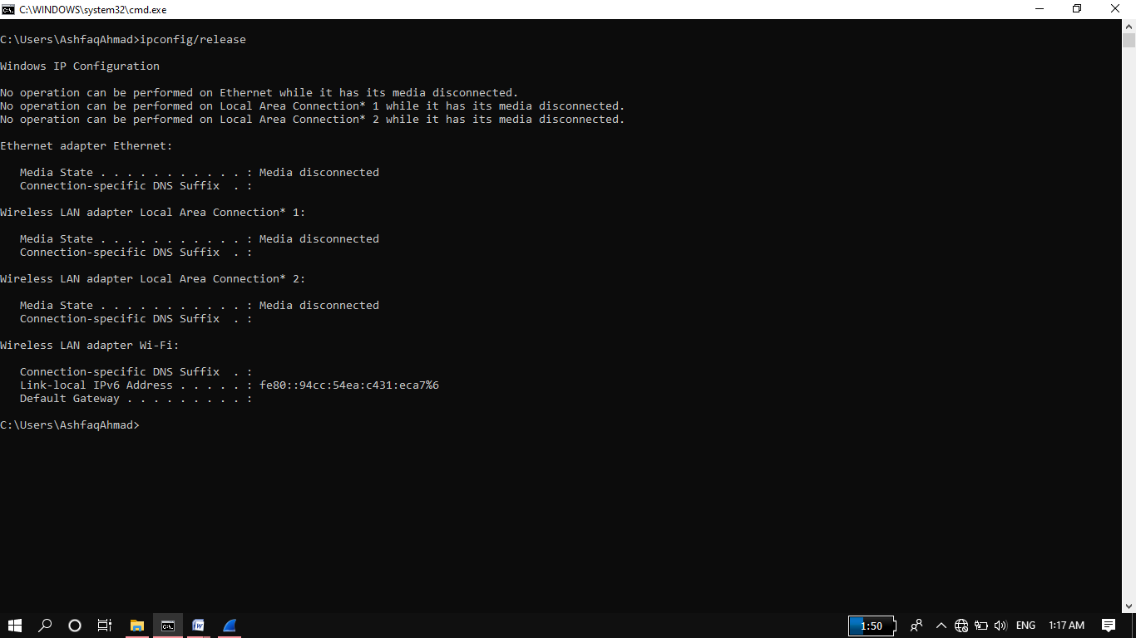

1. Start up the Wireshark packet sniffer, as described in the introductory Wireshark lab and begin Wireshark packet capture.

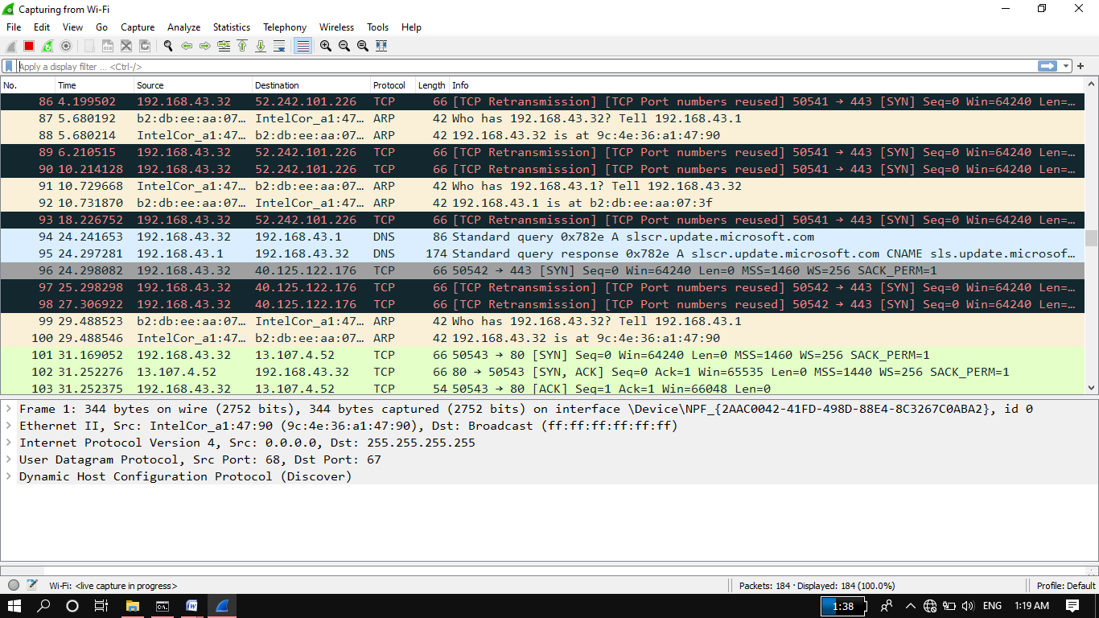

1. Now go back to the Windows Command Prompt and enter “*ipconfig /renew*”. This instructs your host to obtain a network configuration, including a new IP address. In Figure 1, the host obtains the IP address 192.168.1.101

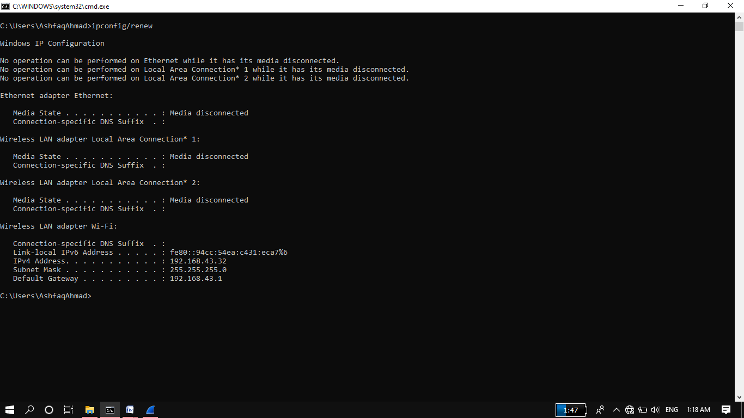

1. Wait until the “ipconfig /renew” has terminated. Then enter the same command “ipconfig /renew” again.

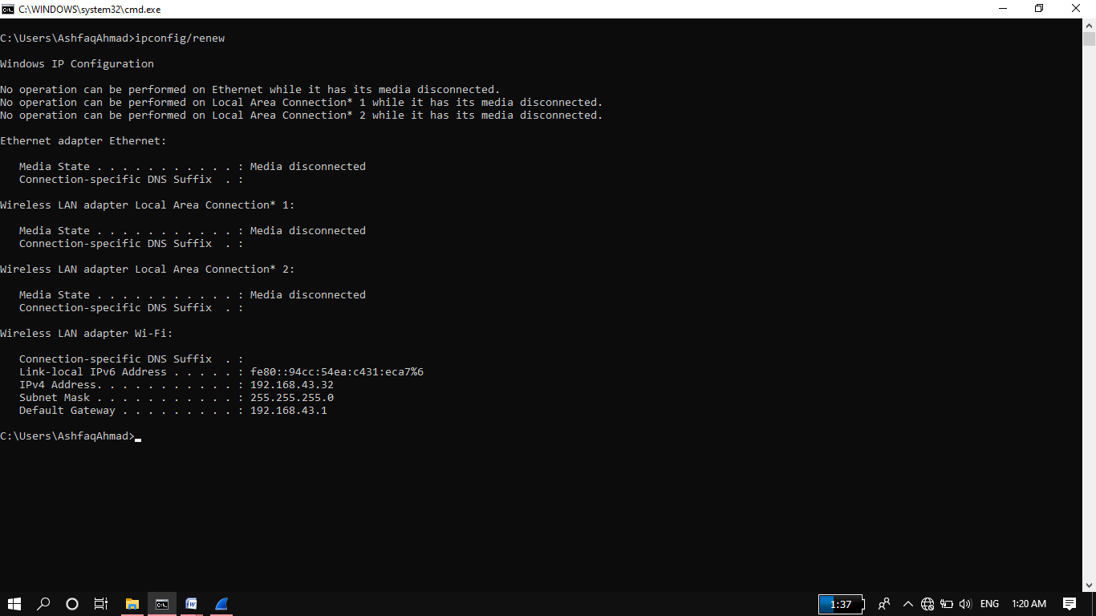

1. When the second “ipconfig /renew” terminates, enter the command “ipconfig/release” to release the previously-allocated IP address to your computer.

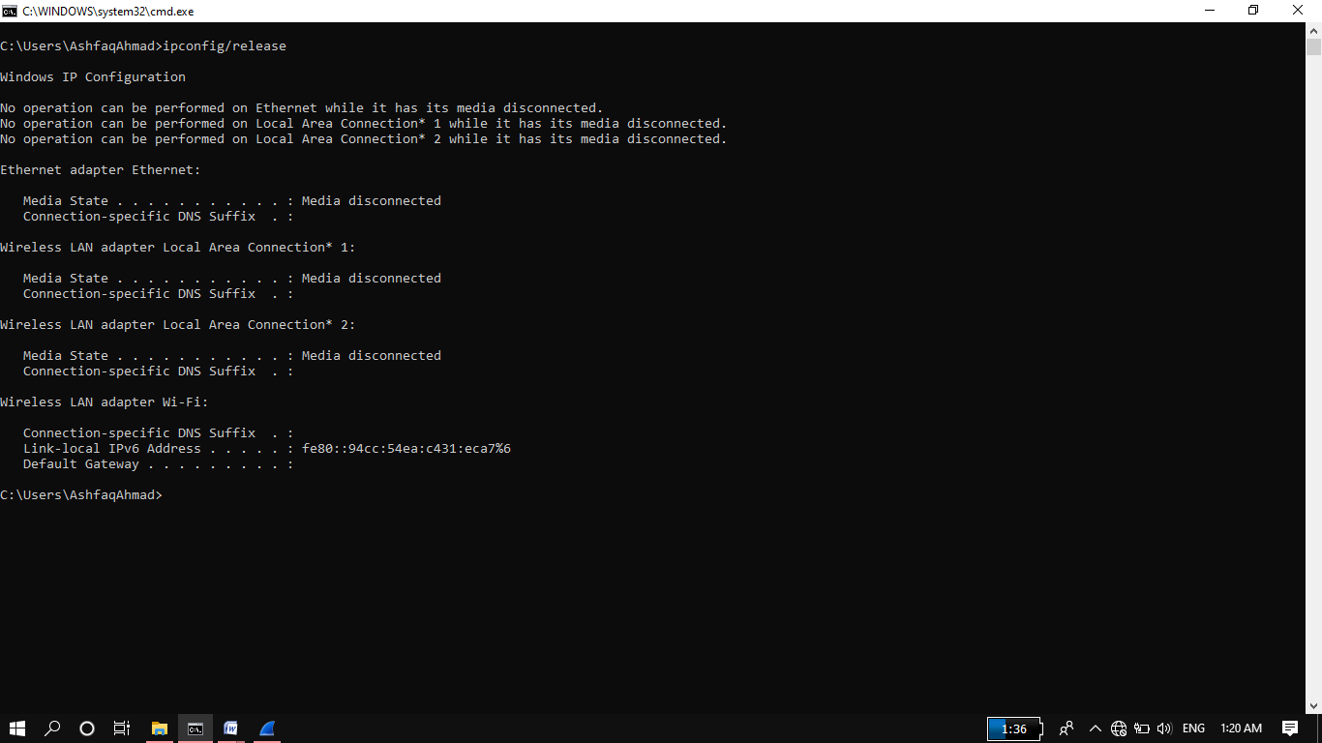

6. Finally, enter “ipconfig /renew” to again be allocated an IP address for your computer.

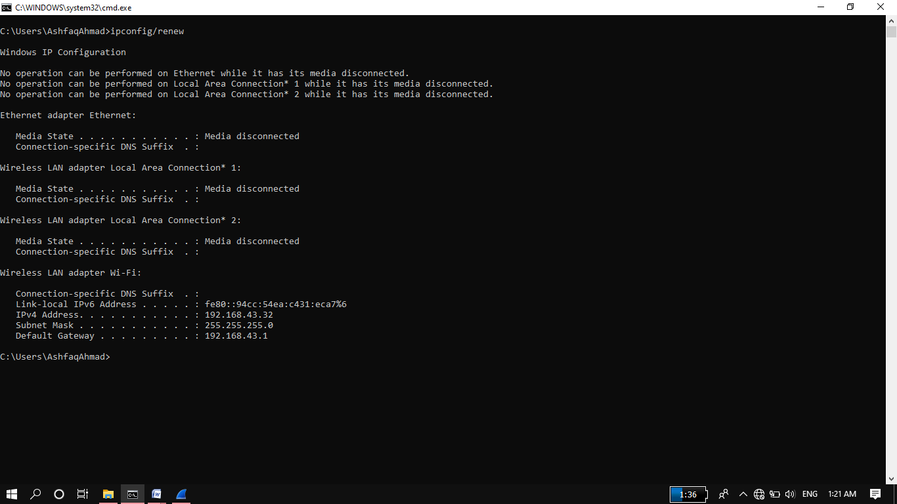

7. Stop Wireshark packet capture.

Now let’s take a look at the resulting Wireshark window. To see only the DHCP packets,

enter into the filter field “bootp”. (DHCP derives from an older protocol called BOOTP.

Both BOOTP and DHCP use the same port numbers, 67 and 68. To see DHCP packets in the current version of Wireshark, you need to enter “dhcp” in the filter.)

We see from Figure 2 that the first *ipconfig* renew command caused four DHCP packets

to be generated: ***a DHCP Discover packet, a DHCP Offer packet, a DHCP Request***

***packet, and a DHCP ACK packet.***

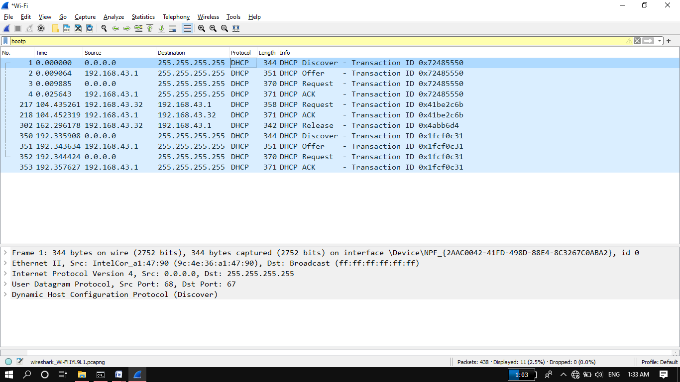

**What to Hand In:**

You should hand in a screen shot of the Command Prompt window similar to Figure 1 above. Whenever possible, when answering a question below, you should hand in a printout of the packet(s) within the trace that you used to answer the question asked.

Annotate the printout3 to explain your answer. To print a packet, use File->Print, choose

Selected packet only, chooses Packet summary line, and selects the minimum amount of packet detail that you need to answer the question.

**Answer the following questions:**

1. Are DHCP messages sent over UDP or TCP?

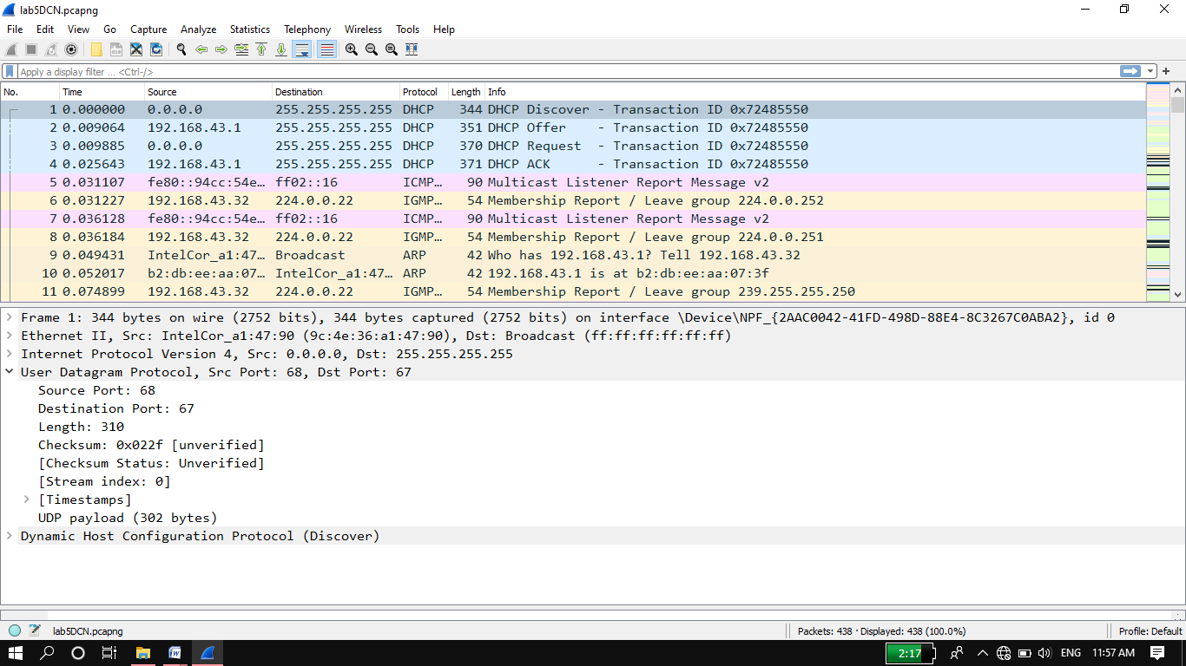 **Answer:** DHCP messages sent over UDP.

1. Draw a timing datagram illustrating the sequence of the first four-packet Discover/Offer/Request/ACK DHCP exchange between the client and server. For Each packet indicated the source and destination port numbers. Are the port Numbers the same as in the example given in this lab assignment?

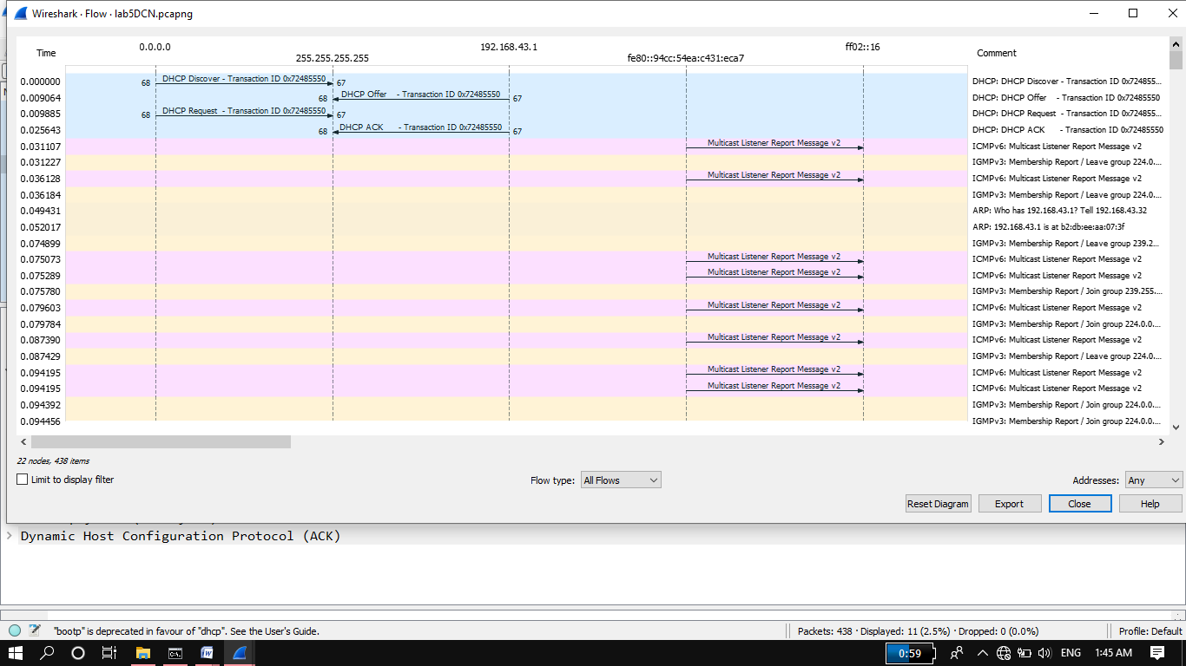 **Answer:** Yes the ports Numbers are same.

1. What is the link-layer (e.g., Ethernet) address of your host?

**Answer:** The link-layer address is **b2:db:ee:aa:07:3f**

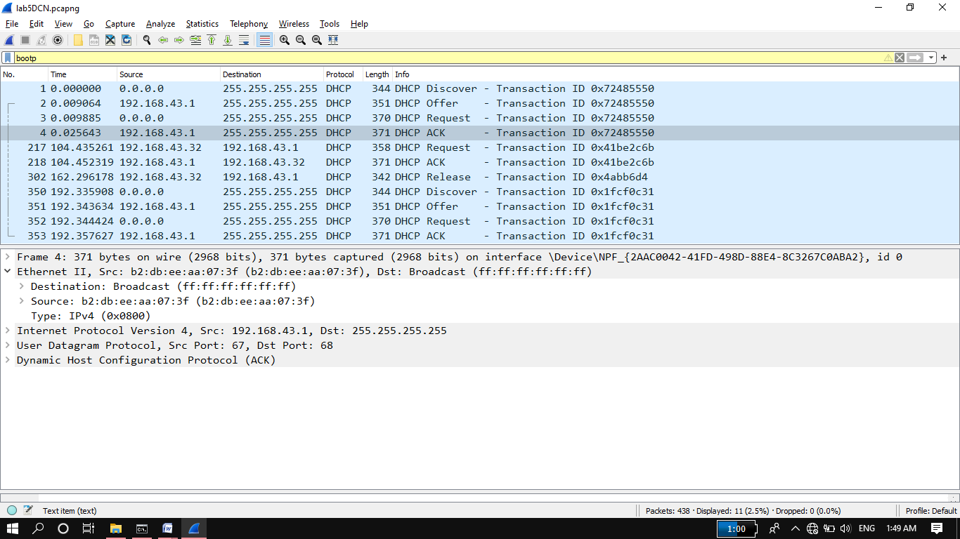

1. What values in the DHCP discover message differentiate this message from the DHCP request message?

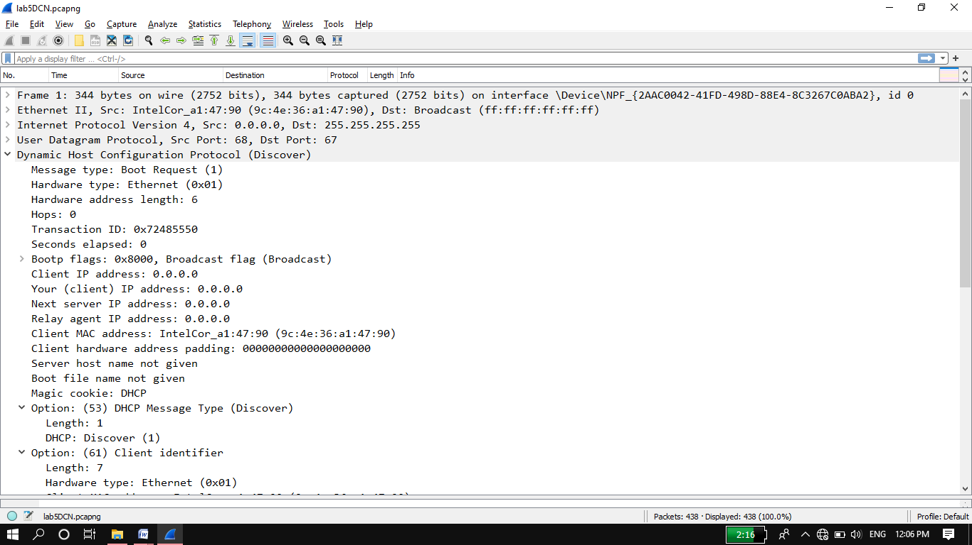

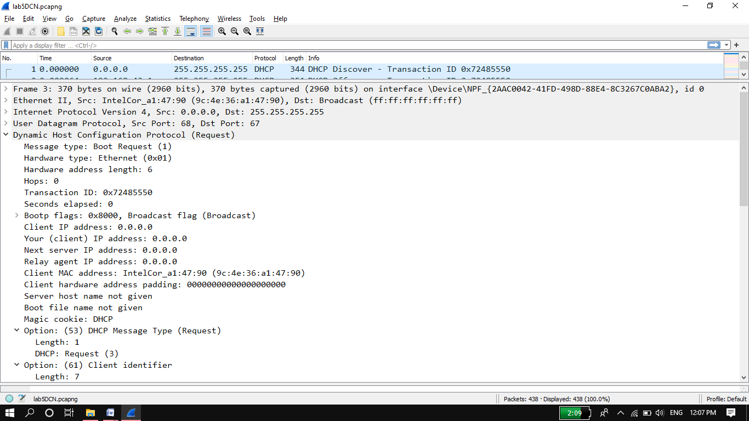

**Option: (53) differentiate DHCP discover and request message.**

1. What is the value of the Transaction-ID in each of the first four(Discover/Offer/Request/ACK) DHCP messages? What are the values of the Transaction-ID in the second set (Request/ACK) set of DHCP messages? What is the purpose of the Transaction-ID field?

**Answer:**

**Discover: -0x72485550**

**Offer: -0x72485550**

**Request: -0x72485550**

**ACK: -0x72485550**

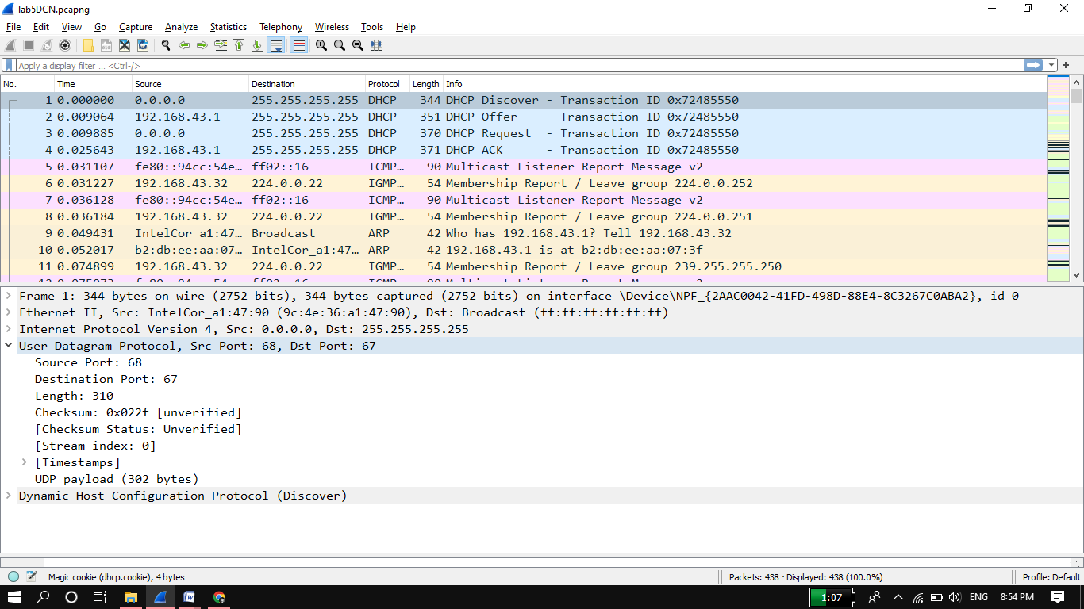

1. A host uses DHCP to obtain an IP address, among other things. But a host’s IP address is not confirmed until the end of the four-message exchange! If the IP address is not set until the end of the four-message exchange, then what values are used in the IP datagrams in the four-message exchange? For each of the four DHCP messages (Discover/Offer/Request/ACK DHCP), indicate the source and destination IP addresses that are carried in the encapsulating IP datagram.

**Answer:** The DCHP client and server both use 255.255.255.255 as the destination address. The client uses source IP address 0.0.0.0, while the server uses its actual IP address as the source.

* **Discover message:** Source IP **(0.0.0.0),** destination IP **(255.255.255.255).**
* **Offer message:** Source IP **(192.168.43.1),** destination IP **(255.255.255.255).**
* **Request message:** Source IP **(0.0.0.0),** destination IP **(255.255.255.255).**
* **ACK message:** Source IP **(192.168.43.1),** destination IP **(255.255.255.255).**

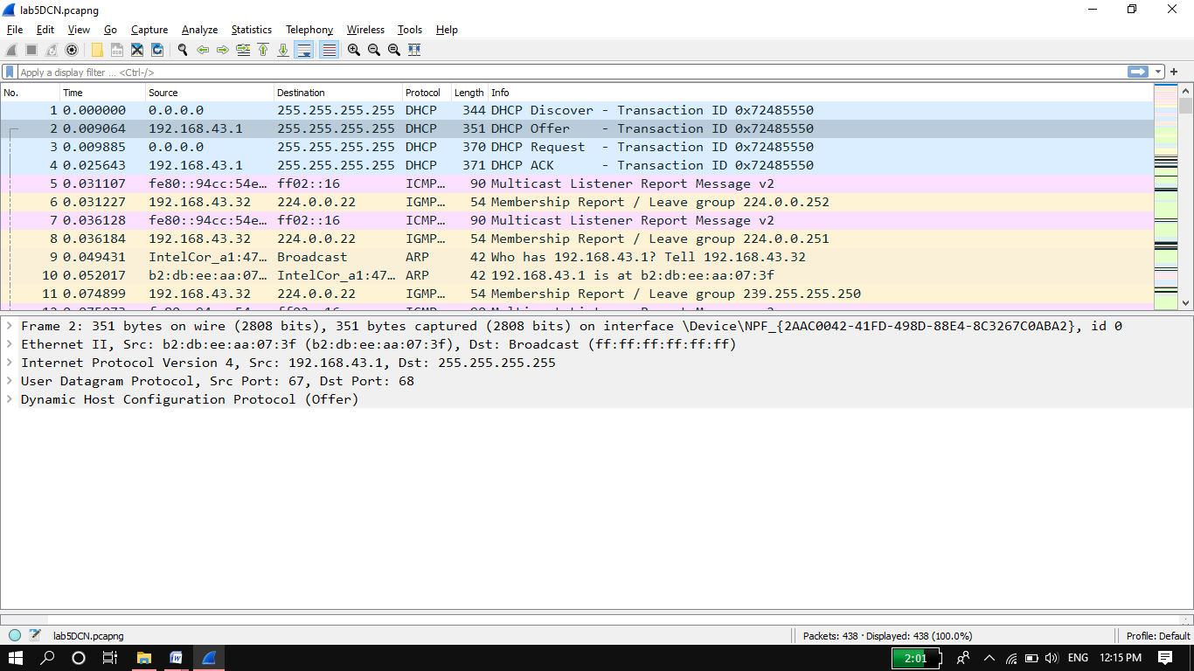

1. What is the IP address of your DHCP server?

**Answer:** **192.168.43.1**

1. What IP address is the DHCP server offering to your host in the DHCP Offer message? Indicate which DHCP message contains the offered DHCP address.

**Answer:** DHCP server offer **192.168.43.32**

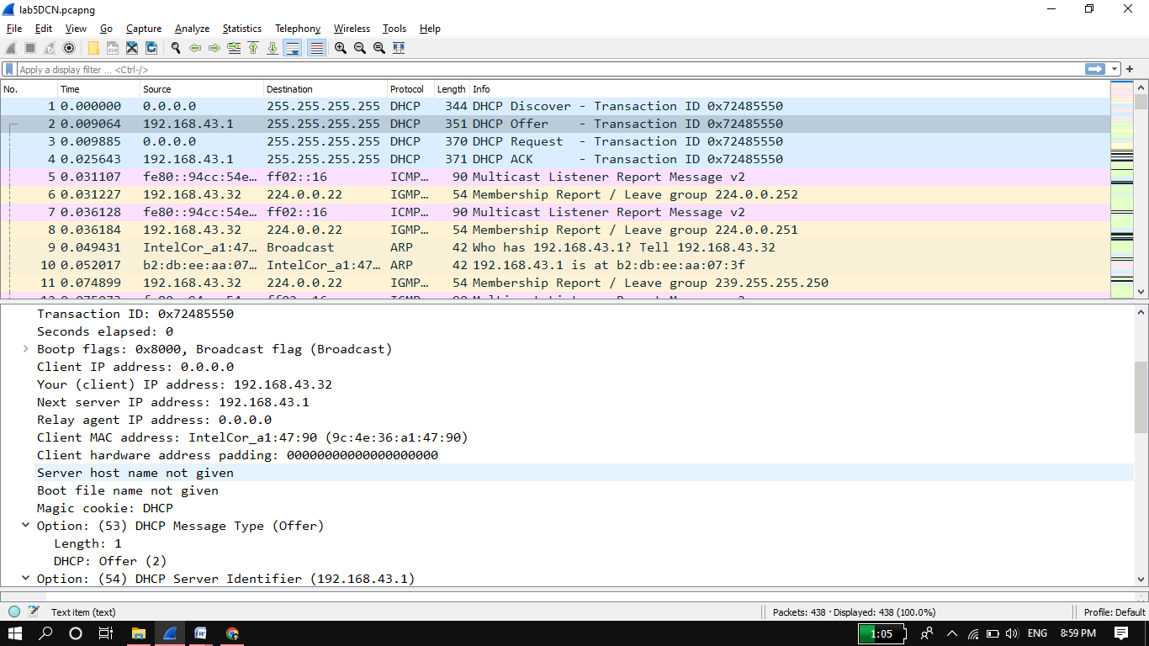

First we will click on offer message then it will show offered IP.

1. Explain the purpose of the router and subnet mask lines in the DHCP offer Message.

**Answer:** The router line indicates to the client what its default gateway should be. The subnet mask line tells the client which subnet mask it should use.

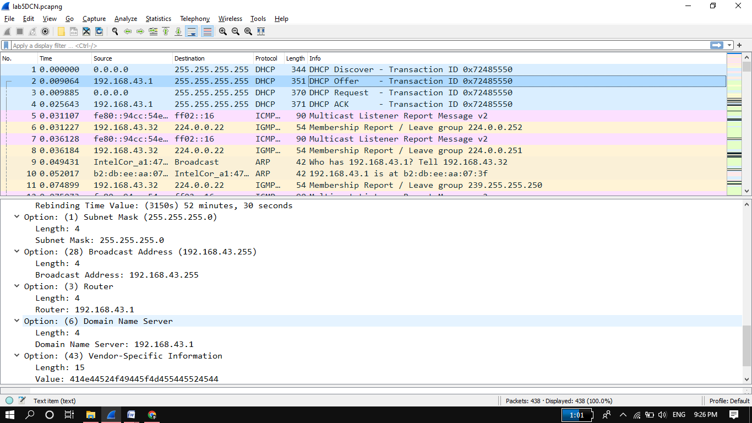

1. Explain the purpose of the lease time. How long is the lease time in your experiment?

**Answer:** The lease time is the amount of time the DHCP server assigns an IP address to a client. During the lease time, the DHCP server will not assign the IP given to the client to another client, unless it is released by the client. Once the lease time has expired, the IP address can be reused by the DHCP server to give to another client. This client again request periodically to DHCP server for new IP address In my experiment, the lease time is 1 hour.

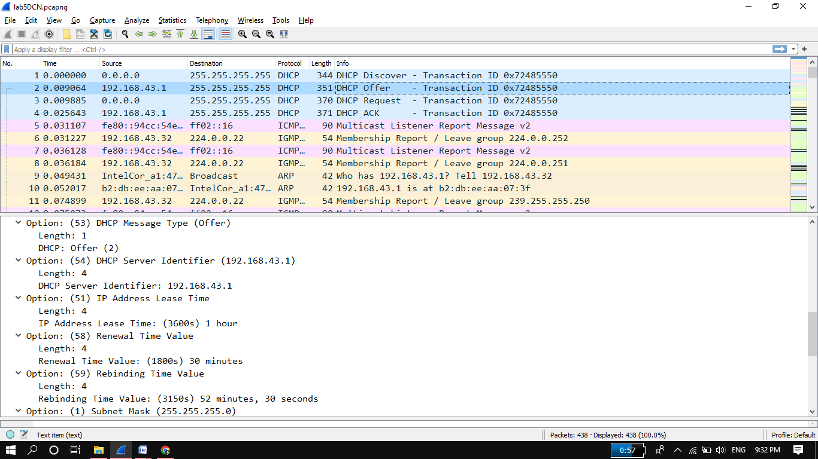

1. What is the purpose of the DHCP release message? Does the DHCP server issue an acknowledgment of receipt of the client’s DHCP request? What would happen if the client’s DHCP release message is lost?

**Answer:** The client send aDHCP release message to cancel its lease on the IP address given to it by the DHCP server. The DHCP server doesn’t send a message back to client acknowledging the DHCP release message. If the DHCP release message from the client lost, the DHCP server would have to wait until the lease period is over for that IP address until it could reuse it for another client.